University of Waterloo

Faculty of Engineering

MTE100/GENE121 Final Project Interim Report – Group 870

by

Jean De Jesus, Sophy Li, Hannah Rosenberg, Shafin Shahriar

Table of Contents

List of Figures iii

List of Tables iii

1 Introduction 4

2 Scope 5

3 Criteria and constraints 6

3.1 Constraints 6

3.2 Criteria 6

4 Design 7

5 Design Decision 10

6 Project plan 11

List of Figures

Figure ‎4.1 Pedal design 7

Figure ‎4.2 Metronome design 7

Figure ‎4.3 Driving arm design 8

Figure ‎4.4 Claw grasping mechanism 8

Figure ‎4.5 Arm pivot design (bottom) 9

Figure ‎4.6 Arm pivot design (top) 9

Figure ‎6.1 Gantt chart for group project schedule 11

List of Tables

Table ‎3.1 Design Constraints of System 6

Table ‎3.2 Design Criteria of System 6

# Introduction

The problem we are attempting to solve is one that musicians encounter regularly during practice sessions. Many musicians struggle to turn the pages of their musical pieces while they are practicing. Having to stop playing to turn a page creates an awkward, unwanted pause in the music. To resolve this need, we will be building a robot that moves pages for the musician when cued to do so. The robot will also have additional built-in features including a metronome and a volume sensor to generally aid musicians in their practice sessions.

# Scope

The main function of our robot will be to move pages of music when cued by the musician. To do so, a mechanical arm sitting on a base will be built with a Tetrix Kit. The base will be driven with continuous Servo motors connected to an EV3 brick. It will sit on a table behind the music stand and reach over to grab the pages with a claw controlled by a standard Servo motor. The music stand height will be adjusted depending on the table available. The pages that the robot is turning will be individual unbound pieces of A size paper, as this is what is most commonly used by orchestra musicians. It will be cued to begin its task when the user hits a foot pedal which will be connected to a touch sensor.

A secondary function of our robot will consist of a metronome that helps the musician maintain proper rhythm. The metronome will be a small rod attached to a standard Servo motor which will hit a pad at a constant speed. This speed will be determined by the user with the buttons on the EV3 base.

Lastly, the robot will use an NXT sound sensor to measure the volume of the music. The musician will use the buttons on the EV3 base to begin the volume detection. Once the time allotted to measure the volume has ended, the robot will display on the screen “Forte,” “Mezzo Forte,” or “Piano” (i.e. loud, medium, or soft).

Overall, our project will have succeeded when the robot is able to move pages of sheet music over when cued, create a constant ticking sound at the speed set by the user, and output the volume range of music played by the user.

# Criteria and constraints

## Constraints

Table ‎3.1 Design Constraints of System

|  |  |
| --- | --- |
| **Constraint** | **Measurement of Success** |
| Grabs page without damaging it | -Arm is able to grasp the page without ripping it  -Determined through trial and observation |
| Moves page in timely manner | -Arm is able to move page within 2-3 seconds  -Determined with timer |
| Moves page on cue | -Arm begins to move when user hits foot pedal  -Determined through trial and observation |
| Arm is stable | -Weight of robot is distributed equally so that it remains upright  -Determined through trial and observation |
| Releases page in correct location | -Releases page only when it is no longer covering next page  -Determined with ruler, approximately 22 cm from start location |
| Accurately detects and outputs volume within set ranges | -Determining the decibel ranges: sound sensor will be tested by playing an instrument and determining the highest and lowest decibel values possible  -This range will be divided into the three specified ranges  -Task will be deemed completed if robot outputs correct volume range of music being played to EV3 screen  -Correct volume will be measured with a decibel meter |
| Metronome creates constant ticking sound | -Amount of time between ticks is consistent and equal to the speed that the user has selected  -Determined with timer |
| Metronome is loud enough to be heard over music | -Volume of metronome ticking is louder than loudest possible music that can be played  -Determined through trial and observation by the musician |

## Criteria

Table ‎3.2 Design Criteria of System

|  |  |  |
| --- | --- | --- |
| **Criteria** | **Measurement of Success of Criteria** | **Benefit to Project** |
| Portability and Weight | Lighter and more compact system (i.e. lower volume and surface area taken up) is better | More convenient for musicians travelling back and forth with music |
| Adjustability of height of robot | If robotic arm height can be adjusted rather than music stand height | Allows user more flexibility in music stand height according to preference |
| Ability to move pages in both directions | If robot can move page back to original location when cued by user | Lessens human interference and added convenience for user |
| Moves pages smoothly | Moves page in one motion without sudden stops or increases/decreases in speed | Less distracting to musician while playing |

# Design

A touch sensor that can be activated by the user will be used to cue the arm to move a page. This mechanism will be a pedal that indirectly hits the sensor using an intermediary pedal (Figure ‎4.1). The metronome will consist of a rod attached to a standard Servo motor that hits a pad using Tetrix pieces (Figure ‎4.2).

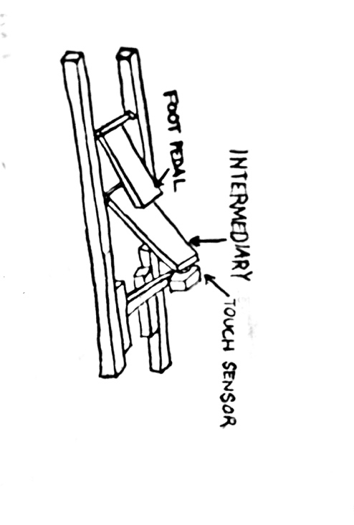

Figure ‎4.1 Pedal design

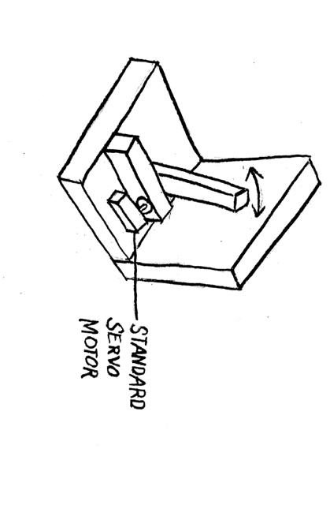

Figure ‎4.2 Metronome design

As for the mechanical arm, one design will involve it sitting on a driving base with four wheels (Figure ‎4.3). The Tetrix claw will reach over the music stand from behind and grab a tab that is perpendicular to the sheet music (Figure ‎4.4). The base will be sitting in a track made of Tetrix pieces attached to the back of the music stand to prevent it from veering off course (Figure ‎4.3). A touch sensor will be attached to one side of the track to cue to robot to stop when it reaches the end (Figure ‎4.3). We will use motor encoders to track how far the robot has moved so that it can return to its original location.

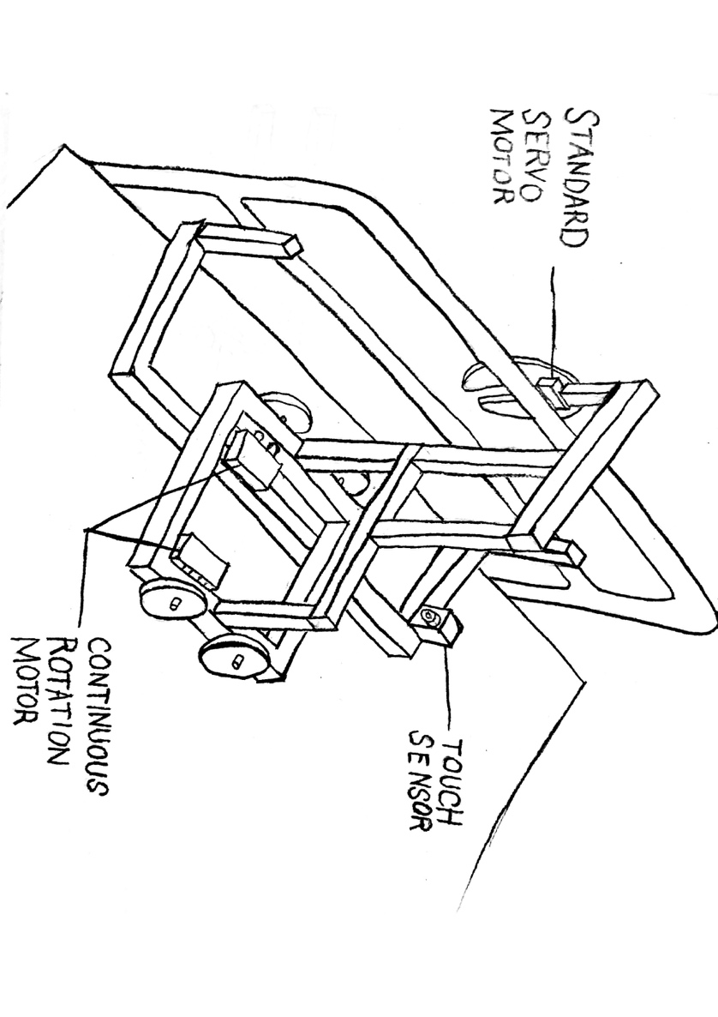

Figure ‎4.3 Driving arm design

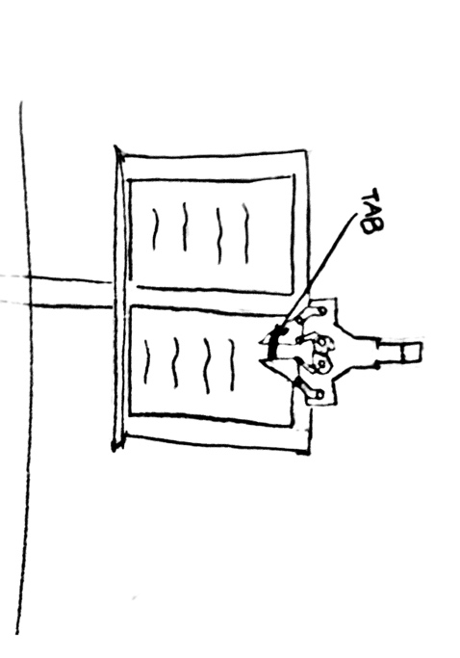

Figure ‎4.4 Claw grasping mechanism

Another potential design would involve a mechanical arm on a stationary base placed behind the music stand. A motor would be attached to the bottom of the arm so that it would pivot about the vertical axis of the arm to turn the pages. A touch sensor would be attached to both sides of the claw so that when it hits the music stand, it would stop pivoting (Figure ‎4.5).

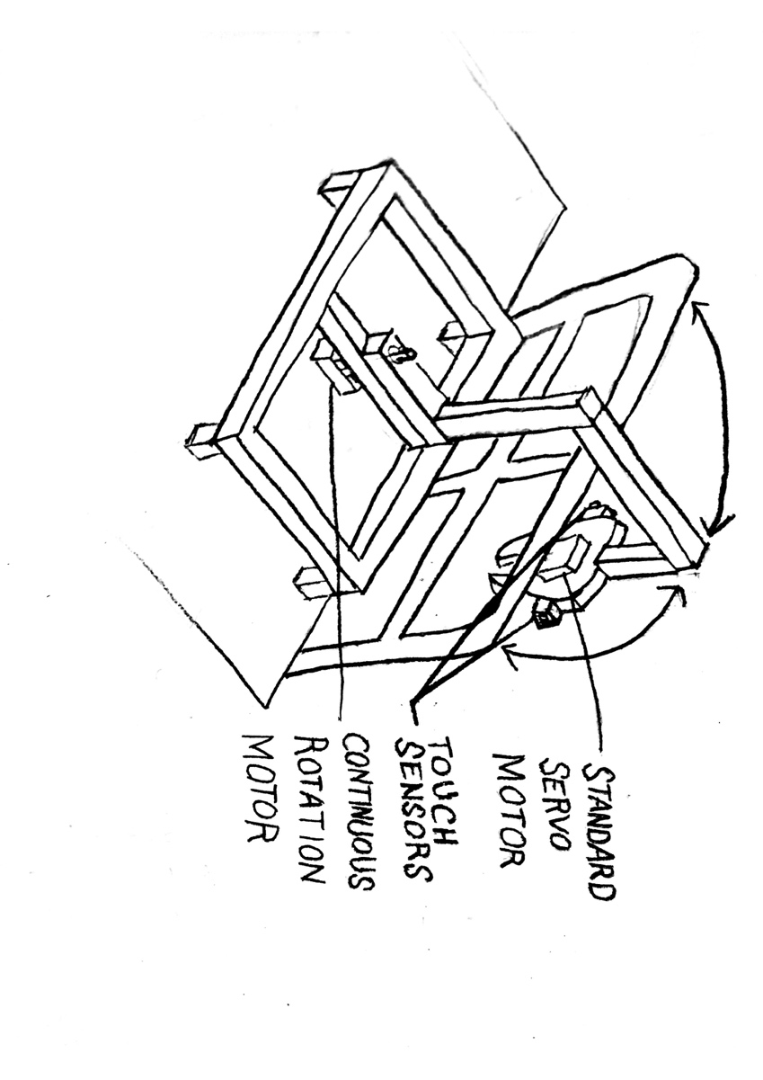

Figure ‎4.5 Arm pivot design (bottom)

The last alternative would also involve a mechanical arm on a stationary base behind the music stand. However, in this design the motor would be placed on top of the arm, causing it to pivot about the vertical axis. A touch sensor would also be attached to both sides of the claw (Figure ‎4.6).

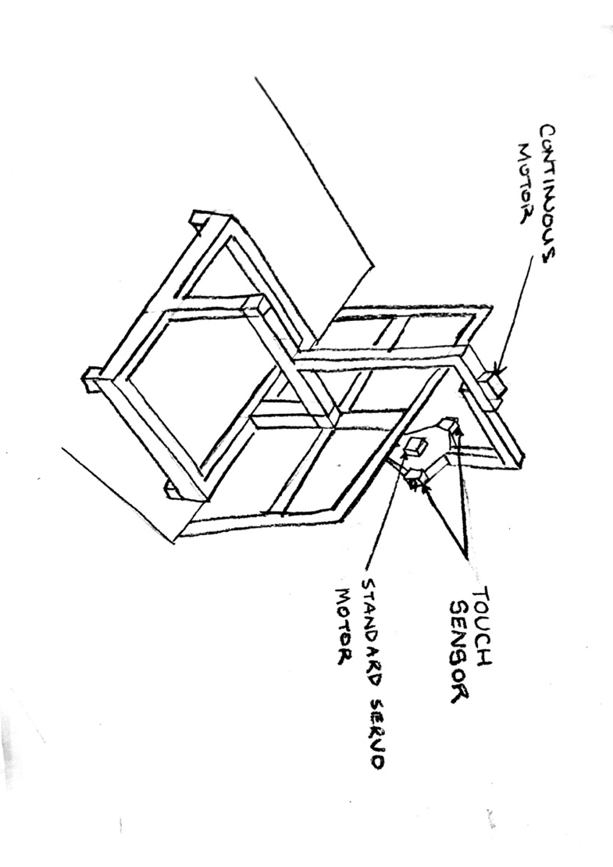

Figure ‎4.6 Arm pivot design (top)

In all designs the sound sensor will be stationed near the musician.

# Design Decision

We intend to pursue the design of the robot that drives in a track as it is the most viable option for a number of reasons. With the pivoting arm design that rotates from the bottom, the motor might not be strong enough to withstand the weight of the arm. For the pivoting arm rotating from the top, the weight distribution could significantly decrease the stability of the robot. Also, we currently do not have access to enough touch sensors to build these two designs without requesting extra hardware.

The gripping mechanism would also be more likely to succeed in the driving robot design. This is because the driving robot would move pages over whereas the pivoting arm design would flip pages. Flipping pages would be much more difficult to achieve. Also, moving the pages over would be more beneficial to the musician as he/she could still see the end of the page while it is being moved. This is a technique that musicians often use while playing.

Lastly, the driving design would be safer as the claw would remain at a constant distance from the music stand at all times. Since the pivoting arm would be rotating about an axis, it would be constantly moving towards or away from the musician. This could be a potential safety hazard. The driving design would decrease the likelihood of the arm hitting the musician or the instrument.

Overall, there is a lower risk of malfunction of the mechanical design with the driving robot over the pivoting arm designs.

# Project plan



Figure ‎6.1 Gantt chart for group project schedule